Shire of Goomalling

Disability Access and Inclusion Plan

2006 - 2011

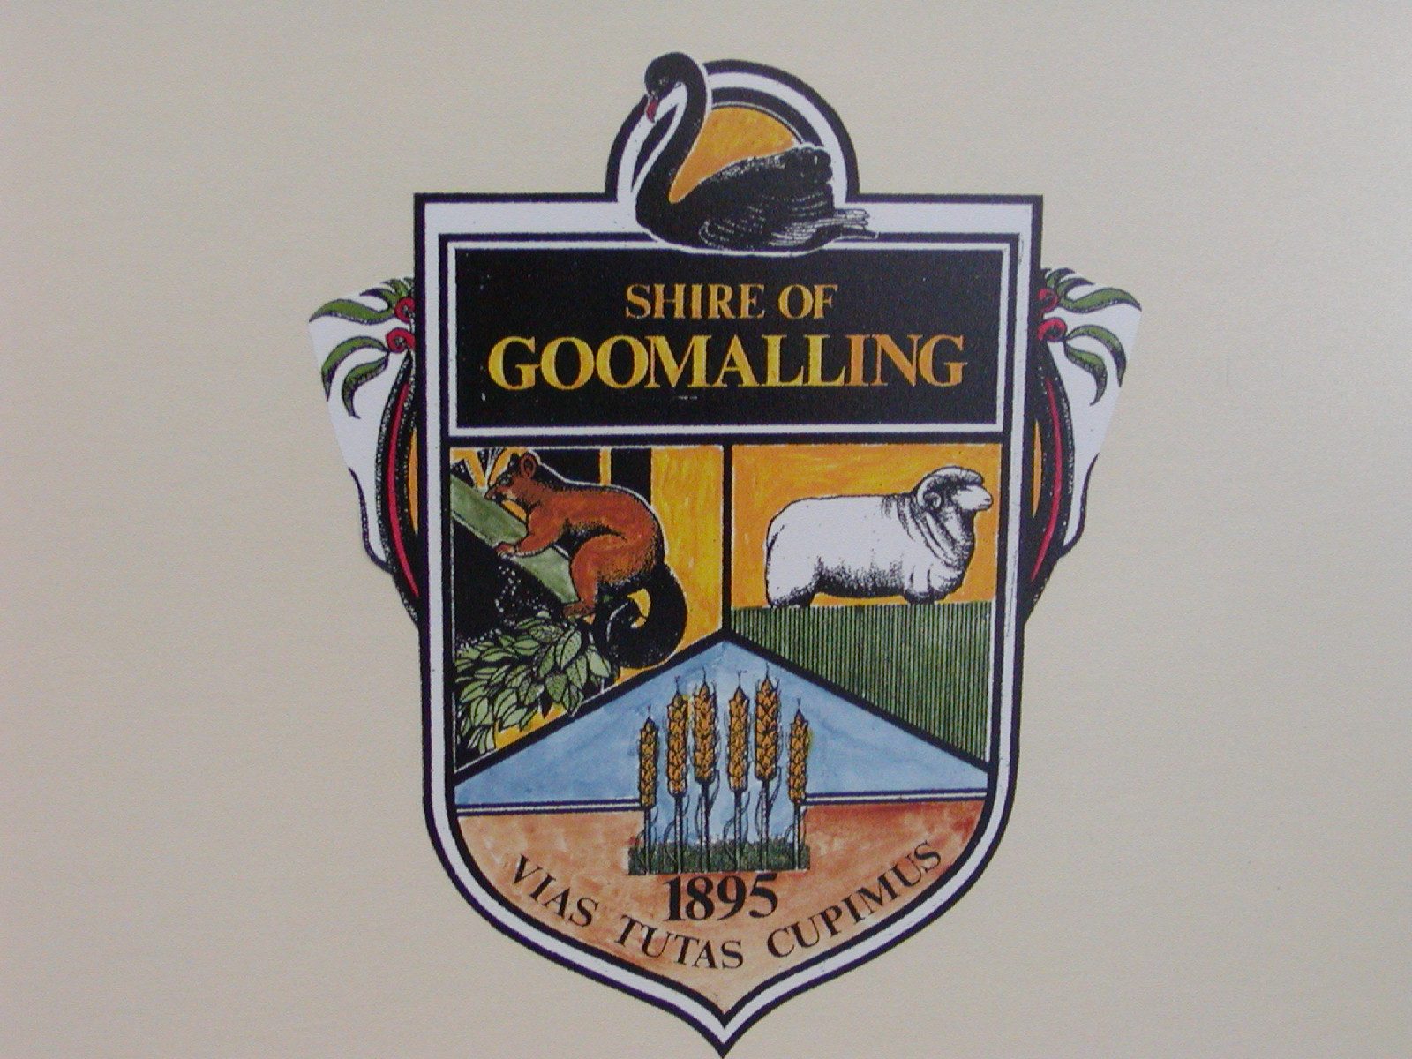

Information Access:

This document explains how Council will improve access to functions, facilities and services for people with disabilities provided by the Shire of Goomalling in accordance with outcoEHO areas and Standards as stated within the Western Australian Disability Services Act (1993)

If you have any questions or would like to feedback regarding barriers to access or require this document in an alternative format such as large print, please telephone the Shire of Goomalling on
96 291 101 or, fax 96 291 017 or alternatively email admin@goomalling.wa.gov.au

Table of Contents

1. Executive Summary…………………… ……………………………………...………………………….3
2. Introduction……………………………………..……………….…………..……………………………...3
3. Access and Inclusion Statement……………………………………………………………………....…5
4. Demographic indicators of disability within the Shire of Goomalling……………...……..………5
5. Relevant Legislation, Codes and Guidelines……………………..……………………………………7
Disability Services Act 1993……………………………………………………….….7
Commonwealth Disability Discrimination Act 1992 (DD………….………………..7
Building Code Of Australia……………………………………………………….……8
6. Role Of Council…………………………………………………………………..……………………..…...8
7. Disability Service Plan 1996 -2005 Access achievements……………………………...……..…….9
8. Development of the Access and Inclusion Plan……………………………………...…………..…..10
Community Consultation………………………………………………………………10
Public Exhibition………………………………………………………………………..10
9. Community Consultation – Access and Inclusion Barriers……………………………...…………11

10. Progressing the Access and Inclusion Plan………………………………...……………..…………13

11.Conclusion…………………………………………………………………………………………………..13

Section B: Progress of Disability Service Plan from 1996…………………………………………….14

Shire of Goomalling Access and Inclusion Action Plan…………………….………………..…………16

Appendix A: Townsite of Goomalling……………………………………………………………………....21

Appendix B: Glossary of Terms and List of Acronyms (Responsibility)……………………………..22

Appendix C: Disability Access Advisory Committee – Terms of Reference…………………………23

Appendix D: Key Contact Service Providers……………………………….……………………………...23

- Executive Summary

The Western Australian Disability Services Act (1993) requires all State and Local Government Authorities to implement a Disability Access Inclusion Plan.

The Shire of Goomalling formally adopted the Disability Access and Inclusion Plan 2006-2011 at the Ordinary Council Meeting on Tuesday 25th July 2006 will be referred to hereon as the Access and Inclusion Plan 2006-2011.

The overarching goal of the Access Inclusion Plan 2006-2011 is to provide equity of access and inclusion to Council services, facilities and functions provided by the Shire of Goomalling by identifying and redressing barriers that either restrict or prevent the full participation of people with disabilities.

Community consultation was undertaken with a broad spectrum of stakeholders inviting contributions from; local residents, disability service providers, Elected Members, Council Staff and the Shire of Goomalling Disability Access Advisory Committee.

Responses received through community consultation and findings based on recent research relating to barriers accessing respite, in-home support and recreation formed on the basis in which actions have been identified within the six (6) outcome areas of the Access and Inclusion Plan 2006-2011.

- Introduction

The Shire of Goomalling acknowledges that people with disabilities are valuable members of the community who have the same fundamental rights as all other residents to access services, functions and facilities. The Access and Inclusion Plan June 2006 - June 2011 provides the Shire of Goomalling with a framework to address barriers to access and inclusion across all areas of Council responsibility.

The Shire of Goomalling realises the importance of developing a forward plan to ensure that both the physical infrastructure and the communities’ perception and awareness of the needs of people with a disability is enhanced through education.
Given the enormity of the task the plan sets to ensure that areas of the greatest need and impact for people with a disability are initiated first.

The Shire of Goomalling is committed to achieving initiatives within the following six (6) Outcome areas and Standards as prescribed within the Disability Service Act (1993).

Outcome 1: People with disabilities have the same opportunities as other people to access the services of, and any events organised by, the relevant Public Authority.

Standard: A disability access and inclusion plan must provide a means of ensuring that people with disabilities have the same opportunities as other people to access the services of, and any events organised by, the relevant public authority.

Outcome 2: People with disabilities have the same opportunities as other people to access to buildings and facilities of the relevant public authority.

Standard: A disability access and inclusion plan must provide a means of ensuring that people with disabilities have the same opportunities as other people to access the buildings and other facilities of the relevant public authority.

Outcome 3: People with disabilities receive the information from the relevant public authority in a format that will enable them to access the information as readily as other people are able to access it.

Standard: A disability access and inclusion plan must provide a means of ensuring that people with disabilities receive information from the relevant public authority in a format that will enable them to access the information as readily as other people are able to access it.

Outcome 4: People with disabilities receive the same level and quality of service from the staff of the relevant public authority.

Standard: A disability access and inclusion plan must provide a means of ensuring that people with disabilities receive the same level and quality of service from the staff of the relevant public authority as other people receive from that authority.

Outcome 5: People with disabilities have the same opportunities as other people to make complaints to the relevant public authority.

Standard: A disability access and inclusion plan must provide a means of ensuring that people with disabilities have the same opportunities as other people to make complaints to the relevant public authority.

Outcome 6: People with disabilities have the same opportunities as other people to participate in any public consultation by the relevant public authority.

Standard: A disability access and inclusion plan must provide a means of ensuring that people with disabilities have the same opportunities as other people to participate in any public consultation by the relevant public authority.

- Access and Inclusion Statement

The Shire of Goomalling is committed to furthering the principles and outcomes of the Disability Services Act (1993) (amended 2004) and meeting the 6 Standards in the Disability Services regulations 2004.
The Access and Inclusion Statement of intent has been developed as a commitment by the Shire to enhance inclusion by providing access for people with disabilities to its services, functions and facilities the following documents were referred to:

- Shire of Goomalling strategic plan 2004 – 2013;
- Disability Service Plan 1996 – 2005
- Responses from the Access and Inclusions Plan Community Consultation

Council adopted the following Access and Inclusion Statement below as recommended by the Shire of Goomalling.

“The Shire of Goomalling endeavours to provide universally accessible and inclusive services and facilities for all people within the community”

4. Indicators of disability within the Shire of Goomalling

Australia’s expanding ageing population is set to impact upon the community over the next two decades. An ageing population increases the likelihood of individuals acquiring a disability include life chances, heredity and environmental influences.

The West Australian Disability Services Act (1993) defines a disability is a condition that:

- Is attributable to an intellectual, cognitive, neurological, sensory or physical impairment or a combination of those impairments;
- Is permanent or likely to be permanent
- Which may or may not be episodic in nature; and which results in;
  - A substantially reduced capacity of the person for communications, social interaction, learning or mobility ; and
  - A need for continuing support services.

The Shire of Goomalling are fortunate to have a Home and Community Care (HACC) service located in the district supporting people with a wide array of support services. There are a few with a disability that frequently use the Shire for a wide range of reasons whether that is to recreate, to visit or for employment opportunities.

There are an estimated 1008 people residing in the Shire of Goomalling according to the Australian Bureau of Statistics (Census 2001).

Shire of Goomalling Key Social Indicators:

Age

The total population for the Shire of Goomalling was 1008 (Census 2001) It is estimated that residents aged 60 years and over represented 16% of the total population.

The median age of the population in Goomalling is 35 years, which is younger than that in the region and older than that in the state. Compared with WA, Goomalling has a larger proportion of people aged between 20 and 35.
There are 9 percent more males than females in Goomalling, compared with 8 percent more in the region and 1 percent fewer in WA. Indigenous people represent 2.5% of the total population, which is much less than that in the region and the state, and 1.8% of the population aged under 18, which is much less than that in the region and the state.

Extent and Type of Disability

Disability, Ageing and Carers (HACC) approximately 45 people residing with some type of disability in the Shire.

The most prominent type of disability was 31 having a physical disability followed by 11 people having a sensory disability. In addition there were 3 people found with a psychiatric disability. It must be noted that many people with disabilities may have one or more disabilities.

Recent research findings from the report “Barriers to respite, in-home support and recreation: a Community Development approach”, reaffirmed synthetic estimates identifying physical and sensory disabilities such as being significantly higher in comparison to other types of disabilities.

Health

Goomalling has a hospital and a resident Doctor. Quamby Lodge is for semi permanent aged care and Sunshine Nursing Home is for acute aged care. There is also 13 aged persons units located close to the hospital.
Further enhanced facilities can be accessed at the Northam Regional Hospital, 50km south of Goomalling.

Income Support

Socio-economic
The unemployment rate was relatively stable in the March 2006 quarter in Goomalling, while it was relatively stable in the region and decreased slightly in the state. In the previous three years unemployment rates in Goomalling were lower than those in the region and the state.
The percentage of those who left school before year 12 in Goomalling was 65%, which is similar to that in the region and greater than that in the state. In Goomalling, the percentage of people who have difficulty with spoken English is much less than that in the region and the state.
The socio-economic indicators, suggest there are no obvious levels of advantage or disadvantage in Goomalling,
compared with the region and the state. The median individual weekly income was $300- $399, compared with $300-$399 in the region and the state. The Index of Advantage - Disadvantage was 944, which is similar to
that in the region and less than that in the state.
The Index of Disadvantage is derived from attributes such as low income, low educational attainment, high unemployment and dwellings without motor vehicles.

Social Security entitlement being received by was the Aged Pension followed by Unemployment Benefits and Disability Support Pensions and persons in receipt of a Carer Payment.

Household Type

There a number of residents living in a lone person household which increases the risk of social isolation although being a small country town, the likelihood of this occurring is considered remote.

5. Relevant Legislation, Codes and Guidelines
Disability Services Act 1993 (DSA)

The Western Australian Disability Services Act 1993 requires all State and Local Government authorities to implement a Disability Access and Inclusion Plan.

The Disability Service Regulations Amendments (2004) dictate how the provisions of the Act are applied to Disability Access and Inclusion Plans which includes:

- Standards for disability access and inclusion plans.
- Information in reports about disability access and inclusion plans
- Publication of disability access and inclusion plans
- Procedure for public consultation by authorities.

Commonwealth Disability Discrimination Act 1992 DDA

The DDA makes it unlawful to directly or indirectly discriminate or impose unjustifiable hardship against a person with any form of disability (i.e. Physical, Intellectual, Sensory, Psychiatric and Neurological). Discrimination as defined by the DDA (1992) is documented as having broad legislative application in:
- work, accommodation, education, access to premises, clubs and sport: and
- the provision of goods and services, facilities, and land : and
- The administration of Commonwealth laws and programs.

The DDA applies to public and private sectors and allows people to complain to Human Rights and Equal Opportunity Commission if they encounter discrimination.

It is the intention of the DDA to eliminate, as far as possible discriminatory practices, but also to promote recognition and acceptance within the community of the fundamental rights of people with disabilities.

The DDA covers a disability which a person has now, may have in the future, had in the past or is assumed to have. The DDA also makes it unlawful to discriminate against a person on the basis that their associate (partner, carer, friend and family member or business partner) has a disability.

The DDA covers existing premises, including heritage buildings, those under construction and future premises. The definition includes not only buildings but parks, pathways and transport systems, streetscapes and play grounds.

Building Code of Australia (BCA)

The BCA references various Australian Standards and Codes to enable the achievement and maintenance of acceptable standards of structural sufficiency, safety (including the safety from fire), health and amenity for the benefit of the community now and in the future.

Part D# of the BCA (Volume One) titled “Access for People with Disabilities” determines which types (Class) and parts of buildings must comply with the access requirements currently referenced by the code.

The BCA is currently under review in the areas of access to align better to the requirements of the Disability Discrimination Act.

Australian Standard (AS) – Design for Access and Mobility.

AS 1428 (Parts 1-4) is an important reference standard which prescribes the basic requirements for physical access for use in the planning, development and construction of all buildings and facilities. Part 1 is a mandatory requirement, as references under the BCA.

The objective of the standard is to provide building designers and users (architects, property owners, regulators and the like) with the minimum design requirements for new building work, to enable access for people with disabilities. The Australian Standard should also be used when providing improved or amended access to existing buildings and is usually used by profession access advisors as the basis for comprehensive access audits to identify access barriers across a wide range of premises.

For more information on relevant legislation, codes and guidelines refer to Appendix A: Key Contact Service Providers.

6. Role of Council

The Shire of Goomalling has a key planning role as a developer and provider of physical and social infrastructure for residents and all people who work, study or visit the district.

The Shire of Goomalling is governed by eight duly elected members of the Council including the President.

The Shire of Goomalling provides a diverse array of functions, facilities and services (in-house & contracted) some of which include:

Processes of Local Government:

Governance, Elections, Council meetings (Committee and Elector Meetings)

Regulatory Services:

Ranger Services, Building Services

General Administration:

Customer Service, Marketing and promotion, Management of Human Resources, finances, information, technology and assets.

Services to Property:

Waste Management, Public Building Maintenance, Transport Infrastructure, Street Lighting, Streetscapes, Roads, Parks

Services to the Community:

Library and Information Services, Environmental Health Services, Recreation Facilities including an Aquatic Centre), Community Development services to youth, the aged and people with disability, Public Events – (e.g. services to youth, the aged and people with disabilities, Public Events – (e.g. Australian Citizenship, Goomalling Field Days), Parks and Reserve, Donations, Sponsorship and Partnerships, Advocacy and leadership roles with government and regional groups.

7. Disability Service Plan 1996 -2006
Access Achievements

This section briefly summarises some of the major achievements made by the Shire of Goomalling through the implementation of the disability service plan 1996 – 2006 to reduce barriers for people living with a disability in the district.

Outcome 1: existing services are adapted to meet the needs of people with a disability.
- All commercial building applications are accessed in accordance to the Building Code of Australia with regard to meeting the provisions for persons who are disabled.
- Procedures have been put in place to insure developers are responsible to maintain pedestrian access.
- Regular street maintenance inspections are undertaken to access safety issues.
- Footpath replacement is a continuing program.
- On going ranger monitoring of ACROD parking bays.
- Increased usage of appropriate signage at public venues.
- Research is continually undertaken to facilitate the development of more appropriate recreation, home support and respite services for people with disabilities.

Outcome 2: Access to buildings and facilities has improved.
- Disability access to all Council buildings were audited (in-house) and access to all has been achieved.
- All commercial building applications are accessed in accordance to the Building Code of Australia with regard to meeting the provisions for persons who are disabled. Liaisons with existing commercial businesses has resulted in most providing appropriate access for the disabled.

Outcome 3: Information about facilities and services is provided in formats which meet the communications requirements of people with disabilities.
- Council Meeting Agenda’s, Minutes and Newsletters are available in large print and via audio tape if requested.

Outcome 4: Councillors and staff members have a greater awareness of the access and services needs of people with disabilities and the knowledge and skills to make the shire accessible to people with disabilities.
- In-house training and staff access awareness has been conducted.
- Improved staff awareness of how to utilise alternative communications formats

Outcome 5: Opportunities are provided for people with disabilities to participate in public consultation and decision making processes are provided.
- Increased opportunities for residents to feedback access issues or concerns through council newsletter.
- Council have provided an advocacy role for people with disabilities referring to matters outside council responsibilities to appropriate departments or organisations.

8. Development of the Access and Inclusion Plan.

Community Consultation:

Residents were invited to respond to Council with any ideas or information that should be included in this Plan. The consultation period of 5 weeks was concluded on 5th July 2006.
No submissions were received.

Public Exhibition:
The Draft Access and Inclusion Plan June 2006 to June 2011 was made available for public comment from July 5th to July 21st 2006. . The Shire of Goomalling Access Inclusion Plan June 2006 to June 2011 will be lodged with the WA Disability Commission and is available from Shire administration, the Goomalling Tele-centre and lodged on the Shire website when completed..

In addition, copies of the Access & Inclusion plan 2006-2011 were distributed to council officers, elected members and local disability service providers within the Shire of Goomalling.

The shire of Goomalling access and inclusion plan 2006 - 2011 is available in range of alternative formats including:
- on request, at the shire offices
- in electronic format ;
- in hard copy format both standard and large print ; and
- on request, by email ; and
- On the website when completed and maintained by the Shire.

9. Community consultation – access and inclusion
barriers

Although there were no submissions, this section summarises a range of issues that Council intends to consider as appropriate to the betterment of the Plan to improve access and inclusion. These issues do not necessary illustrate initiatives council implement to provide continuous access and improvements to core business activities during the term of the access and inclusion plan.

Outcome1 :Existing services are adapted to meet the needs of people with a disability.
- Ensure emergency evacuation procedures for people with disabilities are included in safety programs.
- Ensure information is clear on development applications.
- Improve access to footpaths to promote access to public.
- Provide information centres at open days and include older people.
- Improve promotion at sport and recreational opportunities for people with disabilities by having modified and adaptive equipment for people with low fitness through the Be Active Regional Coordinator.
- Ensure contractors and contractual agreements comply with access standards.
- Review pathway access including kerb cuts located along parks, reserves and major picnic areas.
- Continue improvements to footpaths cycle paths and roads.
- Install flat curbing on central sections of road.
- Provide alternative transport for frail aged people to access the community and council facilities.
- Ensure audio visual equipment is available for presentation that assists people with disabilities.
- Groups are more aware to include people with disabilities.
- Review the extent of accessible parking.
- Ensure ACROD bays are not in need of repair.
- Improve safety in the community.
- Improved traffic movement treatments.

Outcome 2: Access to buildings and facilities is improved.

- Improve pedestrian access from kerbed roads and car parks
- Install ramps and where appropriate automatic doors to other Council buildings
- Provide improved physical access to venues.
- Improve audio system and acoustics In the Council Chamber.
- Signage improvements.
- Facilities available for people with disabilities within Council buildings needs to be written and available at the front counter and also lodged on the Shire website.

Outcome 3: Information about facilities and services is provided in formats, which meet the communication requirements of people with disabilities.

- Provide options for people with disabilities to communicate with Council.
- Promote the positive contributions people with disabilities make toward enhancing the local community.
- Customise information by directly targeting disability service providers to disseminate information.

Outcome 4: Councillors and staff members have a greater awareness of the access and service
needs of people with disabilities and the knowledge and skills to make the Shire
accessible to people with disabilities.

- Provide work placement opportunities for people with disabilities.
- Provide induction and on going training and general disability awareness sessions for staff promoting effective communication strategies for people with various types of disabilities.
- Provide presentations by relevant professionals in the disability field.
- Provide role playing to experience the difficulties faced by people with disabilities.
- Provide positive literature to enhance Access awareness in the private sector.
- Ensure that all staff at recreation facilities has the opportunity to regularly review and update their knowledge, skills and program EHO in relation to catering for people.

Outcome 5: Opportunities are provided for people with disabilities to participate in public
consultations and decision making processes and to have access to grievance
mechanisms.

- Ensure Council meetings are accessible and provide access for people who have specific access requirements.
- Increase resident awareness of Councils commitment to address disability issues in promotional material.

10. Progressing the Access and Inclusion Plan

The effectiveness of achieving outcome actions within the Access and Inclusion Plan is dependent upon a holistic approach involving Council staff and support from Elected Members. Each action within the Access and Inclusion Plan has been recognised as integral to the functioning of a specific section/s of a Council. All Access and Inclusion strategies are linked to internal Corporate Service planning to be implemented over five financial years commencing August 2006, and ceasing June 2011.

The Access and Inclusion Plan 2006-2011 is a dynamic working document which is overseen by the Disability Access Advisory Committee (DAAC), a committee of Council which meets regularly to discuss outcome actions and other issues as seen relevant to the plan.

The Shire of Goomalling Access and Inclusion Plan will be evaluated by:
- An annual report to the Council on the implementation and achievement of the Access and Inclusion Plan including the status of actions scheduled to be achieved over the six (6) outcome areas;
- Additional initiatives;
- And strategies implemented by the Shire of Goomalling to inform its agents and contractors of the Access and Inclusion Plan 2006-2011;
- Community consultation feedback via the Goomalling Despatch or the Shire of Goomalling Community Newsletter.

11. Conclusion

The Access and Inclusion Plan June 2006 - June 2011 has been developed as a strategic means for the Shire of Goomalling to achieve equity of access to Council facilities, functions and services for all people including people with disabilities, their families and carers.

The Shire of Goomalling recognises that community feedback and on-going monitoring is imperative to assist Council to reach its goal.

Progress since 1996 under the
GOOMALLING DISABILITY SERVICES PLAN

- Existing functions, facilities and services are adapted to meet the needs of people with disabilities.

  - Administration staff worked with local non-government disability groups to develop an integration strategy including awareness training for recreation officers.

  - Talking books were relocated to one specific, clearly signed location in the library.

  - A priority bin service was developed to assist people who are unable to move their bin to and from the kerbside.

- Access to buildings and facilities is improved.

- Improved access to the Administration building, including a ramp, contrast edging on steps and relocation of easy access parking bays.

- Access ramps were provided to Council owned buildings, some of which are leased to businesses and provided same to the Post Office.
Bendigo Bank, Telecentre, Go Café, Toy Library, Agricultural Dept Office and
Doctors Surgery.

- Constructed a 4 Unit Motel with one unit fully accessible for persons with disabilities.

- Unisex accessible public toilets built in town centre.

- Footpaths in the main street were upgraded and kerb ramps installed.

- Information about functions, facilities and services is provided in formats which meet the communication needs of people with disabilities.

- An Accessible Information policy was developed.

- Information was made available in alternative formats on request.

- The availability of alternative format information was promoted via local newspaper, radio and disability groups.

- Staff awareness of the needs of people with disabilities and skills in delivering services are improved.

- Key council staff received disability awareness training.

- Opportunities are provided for people with disabilities to participate in public consultations, grievance mechanisms and decision making processes.

- Information about planning processes, electoral processes, council meetings complaints processes was provided in clear and precise language and made available in alternative formats upon request.

- Municipal election voting was held in accessible buildings and some voting booths were modified to suit people using wheelchairs.

Shire of Goomalling

Disability Access and Inclusion Plan

IMPLEMENTATION PLAN

2006 - 2011

Implementation Plan

The Implementation Plan itemises what the Shire of Goomalling will be undertaking in 2006-2011 to improve access to its services, information and facilities for people with disabilities.

The Implementation Plan is presented using a table to outline the:
- individual tasks being undertaken;
- timeline for completion of the individual tasks;
- officer position or part of the public authority with responsibility for completing the individual tasks; and the
- broad strategy that the individual tasks are supporting.

As outlined in the Shire of Goomalling’s DAIP, many of the broad strategies will not be completed in 2006-2011, however individual tasks to support the achievement of those strategies may well be undertaken in part or whole in 2006-2011 through the Implementation Plan.

Broad strategies that will not be achieved in 2006-2011 will be supported by tasks outlined in future Implementation Plans.

Task | Action | Collaborative Partnership | Implementation  Year
1.1 | Review policies and procedures and make recommendations | CEO | 2006 - 2007
1.2 | Conduct an audit of all ACROD Bays, within the Shire of Goomalling (e.g. Signage, line marking, access to pathways) | EHO | 2006 & 2010
1.3 | Review Council Recreation Facilities | EHO | 2007 & 2010
1.4 | Identify and Conduct an Audit of all Footpaths |  | 2007 & 2010
1.5 | Ensure contractual agreements specify standards for the installation of treatments. (e.g. TGSI, Kerb cuts) | CEO | 2006
1.6 | Distribute a pamphlet to assist builders and contractors of the need to comply with BCA and DDA | EHO | 2006 0n-going
1.7 | Develop and implement an ‘Accessible Events’ for use by staff when planning public functions and events. | Admin Staff | 2007
1.8 | The Shires access and inclusion Statement accompanies all requests for seasonal bookings of Council recreation reserves. | Admin Staff | 2007
1.9 | Promote the availability of Concessions available at Council recreation facilities. | Admin Staff | 2007 On-going
1.10 | Encourage sport and recreation clubs booking Council facilities to include people with disabilities | Club Secretary’s | 2007 On-going
1.11 | Undertake seasonal reviews to maintain access to reserve facilities, (e.g. obstructions to pathways, doorways) | Works Supervisor | 2006 & 2010
1.12 | Review processes to ensure contractors and Council Staff maintain a high levels of pedestrian safety when undertaking road and footpath repairs. | Contractors | 2006 On-going
1.13 | Contractors are made aware of their responsibilities to comply with laws including Disability Services Act (1993) within Tender “ Conditions of Engagement” | Contractors | 2006 On-going
1.14 | Include within the selection criteria of tender documents a weighting for contractors to comply with access | CEO | 2006 On-going
1.15 | Conduct road and foot path streetscape access audits to identify safety risks (e.g. kerb cuts, ramps TGSI positioning) | Works Supervisor | 2006 & 2010
1.16 | Assist local businesses with advice to how to s comply with provision for access to/from and within their premises. | EHO | 2006 On-going
1.17 | Investigate the feasibility of utilising existing or developing new forms of community based transport to support people with disabilities to access recreation within the Shire of Goomalling | CEO & DECO | 2008
1.20 | Disability Access is incorporated within the public toilet strategy | EHO | 2006
Outcome 1: People with disabilities have the same opportunities as other people to access the services of, and events, organised by The Shire of Goomalling.

Outcome 2: People with disabilities have the same opportunities as other people to access building and facilities of the Shire of Goomalling

Task | Action | Collaborative Partnership | Implementation  Year
2.1 | Continue to upgrade access to buildings on reserves in accordance with the program of capital works in place | CEO & EHO | 2006 On-going
2.2 | Undertake a disability access signage audit at Council reserve facilities and develop a plan of action | EHO | 2006 & 2010

Outcome 3: People with disabilities receive information from the Shire of Goomalling in a format that will enable them to access the information as readily as other people are able to access it.

Task | Action | Collaborative Partnership | Implementation  Year
3.1 | Undertake a review to ensure that the Shire of Goomalling’s website adheres to compliancy guidelines | Admin Staff | 2006 & 2010
3.2 | Review public print publications to ensure compliance with the Alternative Format procedure. | Admin Staff | 2006 On-going
3.3 | Promote facility upgrades through the Shire of Goomalling’s promotional avenues | Admin Staff & EHO | 2006 On-going
3.4 | Utilise appropriate universal symbols of access in public advertising material | Admin Staff | 2007
3.5 | Provide opportunities for community groups to promote disability awareness campaigns. (e.g. Carers week, Mental health week) | Admin Staff | 2006 On-going
3.6 | Liaise with local disability service providers and recognise contributions made by people with disabilities in the Shire of Goomalling. | Admin Staff | 2006 On-going
3.7 | Lobby the State Government to develop posters and a campaign relating to access in the built environment. (e.g. footpath obstructions including vehicles, overhanging trees) | Admin Staff | 2006

Outcome 4: People with disabilities receive the same level and quality of service from the staff of the Shire of Goomalling as other people receive from the staff of the Shire of Goomalling

Task | Action | Collaborative Partnership | Implementation  Year
4.1 | Review and update the employee induction package to increase staff awareness of the Access and Inclusion Plan | CEO | 2007
4.2 | Conduct Diversity Training to raise staff awareness of disability issues and statutory legislative requirements. | CEO | 2008 - 09
4.3 | Provide training for staff to assist people with various disabilities to evacuate buildings in emergency situations | DECO | 2008
4.4 | Develop procedures for staff to utilise the Australian Communication Exchange to respond to people with various disabilities | CEO | 2009
4.5 | Liaise with disability employment service providers to support people with disabilities into opportunities for Council workplace training | CEO | 2008
4.6 | Provide staff training to assist with challenging behaviours and to use specialised equipment safely. | EHO | 2008 - 9
4.7 | Fund key staff members and DAAC members to participate in external training relevant to the implementation of the Access and Inclusion Plan | CEO | 2008
4.8 | Provide workshops to Councillors to increase awareness of outcomes required within the Access and Inclusion. | EHO | 2007

Outcome 5: People with disabilities have the same opportunities as other people to make complaints to the Shire of Goomalling.

Task | Action | Collaborative Partnership | Implementation  Year
5.1 | Review the grievance procedure takes into account the specific needs of people with disabilities and carers | EHO | 2006

Outcome 6: People with disabilities have the same opportunities as other people to participate in any public consultation by a public authority.

Task | Action | Collaborative Partnership | Implementation  Year
6.1 | Publicly launch the Access and Inclusion Plan | EHO | 2006
6.2 | Incorporate provisions for communicating access requirements into the preparation of community consultation surveys, public launches and public meetings | Admin Staff | 2007
6.3 | Regularly promote in the Council Newsletter contact details to promote and encourage community feedback relating to the Access and Inclusion Plan . | Admin Staff | 2007 On-going
6.4 | Report issues relating to access and inclusion through staff meetings | CEO | 2006 On-going

Appendix A: Townsite of Goomalling

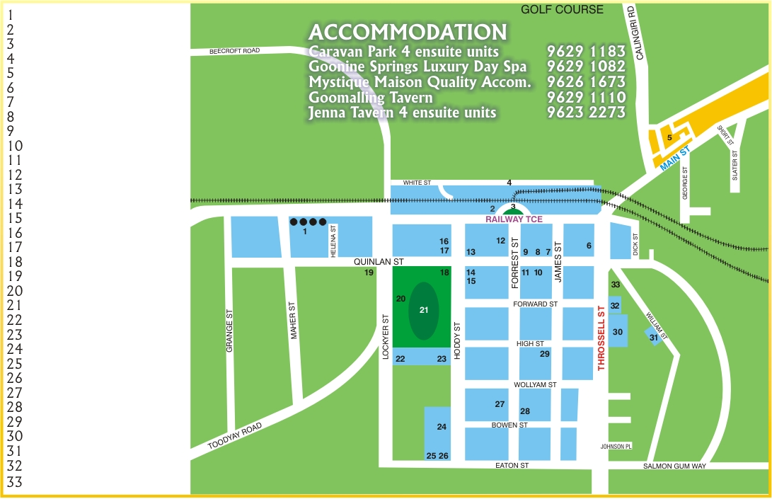

Situated 132 Kilometres North East of Perth, The Shire of Goomalling can be reached travelling via Northam and Goomalling or through Toodyay.
The Shire of Dowerin encompasses the localities of Hulongine, Jennacubbine, Konnogorring, Karranaein, Moombekine, Rossmore, Ucarty West, Walyormouring and Wongamine.

Appendix B: Glossary of Terms and List of Acronyms (Responsibility)

Glossary of Terms
Alternative Formats | The Shire, upon request, will endeavour to make documentation and Council documentation available in a range of formats including; Computer Disks or e-mail attachments of information, which can be enlarged on a computer screen; Enlarged documents in 18 point or higher if required; Enlarged photocopies of documents; Audio cassettes of information; Braille copies of information, including tactual graphics.
Australian Standard | Various Australian Standards set out requirements that must referred to when making decisions that impact on people with disabilities, (e.g. Australian Standard 1428- Design for Access and mobility)
Definitions of Disability | The Commonwealth Disability Discrimination Act 1992 provides protection for everyone in Australia against discrimination based on disability. The definition of a disability in the DDA is as broad as possible and includes; Physical, Intellectual, Psychiatric, Sensory, Neurological, and Learning disabilities, as well as Physical disfigurement, and the presence in the body of disease causing organisms.
Discrimination | Differential treatment or practise either intentional or otherwise that can occur through action, policy, procedure or practice.
Impairment | Any disturbance or interference with the normal structure and functioning of the body, including the systems of mental function. (World Health Organisation) This may or may not be a disability for example high blood pressure is a impairment but not a disability.
Tactile Ground Surface Indicator (TGSI) | A title with raised projections to indicate either danger or a change in level or, to act as a directional guide to people with vision impairment.
Universal Access | Means that a person with a disability is, without assistance, able to approach, enter, pass to and from make use of an area and its facilities.
Universal Design | Product, environment, building design and construction that aims to accommodate the functional needs of everyone; including children, adults and older adults, with or without disabilities. The word universal is often seen coupled to specific design environments or products such as universal kitchen design or universal bathroom design.

List of Acronyms
ABS | Australian Bureau of Statistics
ACROD | Australian Council for Rehabilitation of Disabled.
AIP | Access and Inclusion Plan
BCA | Building Code of Australia
Council | Shire of Dowerin
DAAC | Disability Access Advisory Committee
DDA | Disability Discrimination Act (1992)
DSC | Disability Services Commission of Western Australia
EEO | Equal Employment Opportunities
HREOC | Human Rights and Equal Opportunity Commission
KRA | Strategic Plan Key Result Area
LAC | Disability Service Commission Local Area Coordinator

List of Acronyms (Responsibility)

CEO | Chief Executive Officer
SFO | Senior Finance Officer
DAAC | Disability Access Advisory Committee
WS | Works Supervisor
CDO | Community Development Officer
EHO/BS | Environment and Health and Building Surveyor

Appendix C: Disability Access Advisory Committee
Terms of Reference

The Terms of Reference for the Disability Access Advisory Committee as endorsed at the Ordinary Council Meeting on is as follows:

The Disability Access Advisory Committee will provide strategic advice pertaining to outcome areas and actions as stated within the plan relevant to the Disability Services Act (1993) by:
- Recommending solutions that contribute to enhancing the quality of life of all residents including people with disabilities in respect to universal access and inclusion to Council facilities, services and functions.
- Reviewing and monitoring the implementation of the plan relevant to the Disability Services Act (1993).

Appendix D: Key Contact Service Providers

Advice Provider | Telephone | Fax | E-mail
ACROD – National Industry Association for Disability Services | 9242 5544 | 9242 5044 | acrodwa@acrod.org.au
Association for the Blind | 9311 8202 | 9361 8696 | mailbox@abwa.afn.au
Disability Service Commission | 9462 9200 | 9226 2306 | access@dsc.wa.gov.au
People with Disabilities (WA) Inc | 9386 6477 | 9386 6705 | info@pwdwa.org
Human Rights and Equal Opportunities Commission | 1300 369 711 |  | complaintsinfo@humanrights.gov.au
Sussex St Community Law Service | 9470 2676 | 9470 1805 | sscls@sscls.com.au
Independent Living Centre | 9381 0600 | 9381 0611 | enquiries@ilc.com.au
Shire of Dowerin Council | 96311 202 | 96311 193 | admin@dowerin.wa.gov.au

For Information relating to community service providers that provide social or in-home support services for people with disabilities, older persons or Carers please contact the Commonwealth Carelink on 1800 052 222

