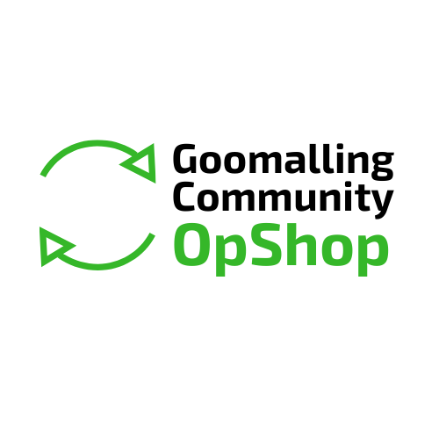

Activate Goomalling Grant Program 2024 – Round 6

**Final Report**

## Section One – Applicant Details

**1.1** **Organisation**

|  |  |  |  |
| --- | --- | --- | --- |
| Legal name of organisation: |  | | |
| Trading name (if applicable): |  | | |
| ABN/Incorporation No. |  | | |
| Postal address: |  | | |
| Suburb: |  | Postcode: |  |
| Telephone: |  | | |

## Section Two – Project Details

### 2.1 Project/Program Name:

### 2.2 What are the benefits of your project/program to the community?

## Section Three – Project Financials

**Do not include GST**

|  |  |  |  |  |
| --- | --- | --- | --- | --- |
| **(1)**  **Description** (i.e. what the money will be spent on | **(2)**  **This Grant Amount** ($) (excl. GST) | **(3)**  **Other Funding Amount** ($) (excl. GST) | **(4)**  **In-Kind Support** Please estimate the dollar value of the in-kind support ($) | **(5)**  **Source of Other Funding or In-kind Support** Please state if confirmed or unconfirmed |
| Catering | $500.00 | $2000.00 | $500 |  |
|  |  |  |  |  |
|  |  |  |  |  |
|  |  |  |  |  |

## Section Four - Declaration

On behalf of the applicant organisation, I declare that:

* I am currently authorised to legally enter into contracts on behalf of the organisation, according to its constitution or as bound by law.
* All the information provided in this report, including any attachments, is true and correct.
* The organisation is financially viable and able to meet all accountability requirements.
* I give permission to the Goomalling Community Opshop, when applicable, to contact any persons or organisation in the processing of this report and I understand that information may be provided to other agencies, where appropriate.
* I confirm that all grant funding was spent in accordance with the grant letter of agreement.

|  |  |
| --- | --- |
| Name of the organisation |  |
| Legally authorised officer name |  |
| Legally authorised officer position |  |
| Legally authorised officer telephone |  |
| Legally authorised officer email |  |
| Legally authorised officer signature |  |
| Witness name |  |
| Witness signature |  |
| Date |  |

## Application Checklist

Before applying, ensure the following have been completed and checked:

|  |  |
| --- | --- |
| **Checklist item** | **Complete** |
| All question in report completed |  |
| Copy of invoices from suppliers attached |  |
| Photo evidence attached |  |
| Invoice to the Goomalling Community Opshop for grant amount attached |  |

## Report submission

via **email:** cdo@goomalling.wa.gov.au (preferred)

**in person** to: 32 Quinlan Street, Goomalling WA 6460 OR

**Post to:** PO Box 118, Goomalling WA 6460

**Grant funds will not be paid until report is received**

All applications will be acknowledged via email within five business days of receipt. Contact the 08 96291101 or [cdo@goomalling.wa.gov.au](mailto:cdo@goomalling.wa.gov.au) to confirm receipt if no acknowledgement is received by this time.