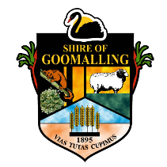
SHIRE OF GOOMALLING
Office address: 32 Quinlan Street, Goomalling WA 6460
Postal address: PO Box 118, Goomalling WA 6460
Phone: 9629 1101 Email: goshire@goomalling.wa.gov.au

CERTIFICATE OF STRUCTURAL SUFFICIENCY (DESIGN)

The purpose of this certificate is to provide the Shire with assurance that the structural design of the nominated building complies with the requirements of Section 1.2.2 (Evidence of Suitability) of the Building Code of Australia 2015. It is not intended for the use by other parties and any such use shall only be approved by the issuer.

ADDRESS OF PROPOSED CONSTRUCTION:

DESCRIPTION OF WORKS:

I/We certify that:

The nominated building complies with the requirement in Section 1.2.2 (Evidence of Suitability), of the Building Code of Australia 2015.

In my opinion, the structural design for strength, serviceability and fire protective properties of the structural elements of the building, comply with the intent of the Building Code of Australia and all relevant SAA Codes including AS1170.2-2011; AS2870 2011; AS4055 2012; AS4100-1998; AS/NZS 4600 2005.

Declaration:
I am practicing as a qualified Professional Engineer (structural) as defined in the Building Code of Australia.

STAMP: >>

Signature: ______________________ Date: _________________

